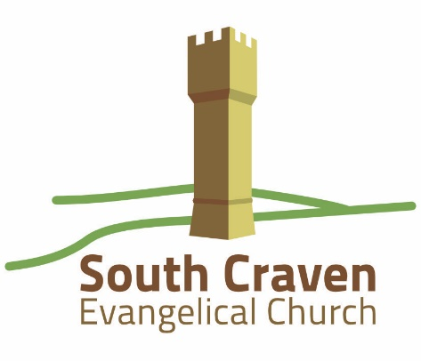

**Back Colne Lane**

**Cross Hills**

**West Yorkshire**

**BD20 8TS**

**CIO Charity Number 1200255**

**Full Time Permanent Pastor Role**

**Why?**

South Craven Evangelical Church (SCEC) is seeking a full time, permanent Pastor. This man* will be a paid Elder within the Eldership Team, with the main responsibility for preaching and teaching. He will also help us in sharing the good news of Jesus in this area of England. We aim to make Jesus the centre of our lives together as a church family, as we live for God in our daily lives, and as we open His Word to discover what He is teaching us about Himself, our work, our families and our culture.

We know that it is essential that any full time worker is cared for by the fellowship and we are committed to supporting, loving and nurturing our Pastor. We believe that the Bible teaches a plurality of Elders as the best leadership model for a church, and that this includes a clear structure of mutual accountability. We also seek to offer a financial remuneration that is a living wage and is as generous as possible.

**\* Important requirement**. In line with our theological position, this pastoral role is open to male applicants only.

**Who are we?**

We are a group of believers and their families, currently aged 0 – 94 and of various backgrounds, who have been saved by the grace of God. Sunday morning congregations are up to 60; evening congregations are smaller. The majority of our members either live within walking distance of the church building or travel from nearby villages that have no current evangelical work. In recent years we have planted a church in the neighbouring town of Keighley. You can read more about us here:

<https://southcravenevangelicalchurch.co.uk/>

**What do we believe?**

SCEC is focused on Jesus Christ as Lord and Saviour, keeping the gospel at the centre of everything we do. We are affiliated to the Fellowship of Independent Evangelical Churches (FIEC), a nationwide network of around 600 churches, and are in full agreement with the FIEC Doctrinal Basis:

<https://fiec.org.uk/who-we-are/beliefs>

**Where are we?**

We are based in Cross Hills, <https://en.wikipedia.org/wiki/Cross_Hills>, a village on the border of West and North Yorkshire. The church building is situated in the middle of three adjoining villages with a total population of around 8000, 50% of whom are aged 18 – 64 years. Church attendance in the area is low, and this is a real mission field.

**What is our purpose?**

By the enabling of the Holy Spirit, and through:

* prayer
* our regular worship
* our small group meetings
* serving together in the ministries of the Church
* sharing our lives and opening up our homes,

we aspire to:

* grow in the knowledge and love of God
* follow Jesus together, becoming more like Him
* make Jesus and His gospel known to our community and beyond.

**What attributes do we seek in a Pastor?**

We are looking for a man who will be a faithful shepherd and teacher. He should:

* satisfy the biblical requirements for an Elder
* be able to declare wholeheartedly his acceptance of the FIEC doctrinal basis and ethos statements
* demonstrate godliness in his devotional life, personal life, ministry and personal relationships
* handle God's word faithfully as he preaches the truth, with application that is relevant
* show care, empathy and understanding to all our Church family
* have a consistent desire to reach the lost
* be able to work effectively as part of an Eldership Team in directing the Church under God
* ideally, have had both pastoral experience and secular employment.

**How would we wish to support a Pastor?**

With God’s help we would seek to:

* pray regularly for him
* recognise his spiritual, emotional, physical and financial needs as an employee of the Church
* respect his and his family’s requirement for time, space and privacy
* support his study and pastoral development.

We would love to hear from you if you are excited by the prospect of working with us for the growth of God’s kingdom and for His glory. We would encourage you to contact us for further details of employment through providing a CV and covering letter to the Elders: [scecpastorvacancy@gmail.com](mailto:scecpastorvacancy@gmail.com)