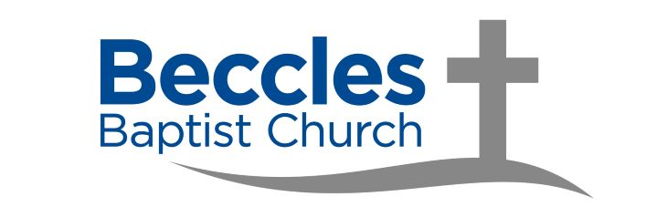
Operations Coordinator
Application form
Please email the completed application form to: tom@becclesbaptistchurch.co.uk
together with: (1) a covering letter; and (2) your CV.

Name:
Address:
Postcode:
Email:
Mobile Phone:

Role Applying for: Operations Coordinator

- Why are you applying for the role of Operations Coordinator at Beccles Baptist Church?

- What skills and abilities fit you for the role of Operations Coordinator?

- What experience will help you in the role of Operations Coordinator?

- Are there any aspects of the role that particularly excite you?

- Are there any aspects of the role you would find more challenging?

- How do you think Beccles Baptist Church will benefit from the appointment of an Operations Coordinator?

References
Please provide us with details of three referees. One of these referees should be your current/most recent employer. One of these referees should be your current minister, if you are applying for this role from a church other than Beccles Baptist Church.

1st Referee (current/most recent employer)
Name:
Relationship:
Email:
Mobile:

2nd Referee
Name:
Relationship:
Email:
Mobile:

3rd Referee
Name:
Relationship:
Email:
Mobile:

Personal information
Do you hold a current full driving licence?
Do you have regular use of a vehicle?
Are there any restrictions on you taking up employment in the UK?
(for more information please see: https://www.gov.uk/prove-right-to-work)
Have you ever been convicted of a criminal offence?

Note: This post is subject to a satisfactory DBS check.
If successful in my application, I agree to complete an Enhanced Disclosure from the Disclosure & Barring Service.

Declaration
I confirm that, to the best of my knowledge, the information given on this form is correct. I understand that false information could lead to dismissal. I consent to the data processing of the information I have given on this form as defined under the Data Protection Act 1998 for the purposes of employment with Beccles Baptist Church.

Signed:

Date:

Proposed Timeline for application process
- Friday 10 July: Role advertised on Beccles Baptist Church and FIEC websites.
- Friday 4 September: Application deadline.
- Friday 11 September: Shortlist of candidates drafted and successful candidates invited for interview.
- Friday 25 September: Interview(s).
- Friday 2 October: Interview (second round, if needed).
- Role beings:
Ideal: Tuesday 2 November (if 1-month notice period needed)
Latest: Tuesday 1 December (if 2-month notice period needed)

